# 21.09.2022

## Administrative:

* 3 things in the course
  + Theoretical (4 hours)
  + Async (2 hours)
  + Homework (2 hours)
* Name of the teacher: David Russo
* To access the cursus on moodle, we just need to change the id of the course or search the course
  + cyberlearn.hes-so.ch/view.php?id=6313
* We will maybe have an exam on the 2nd of November
* We have access to 3 IP Addresses – 1 for windows, 1 for Linux and 1 in reservation
  + 10.130.25.23 (windows) – 24 (Linux) – 25 (reservation)
* Download of Cisco Packet Tracer Student 🡪 is a networking simulation tool

## 7 Layers of the OSI Model Explained - SatomsTheoretical:

The OSI (Open Systems Interconnection) Model describes 7 layers that computer systems use to communicate over a network.

We will learn them starting from the top to the bottom.

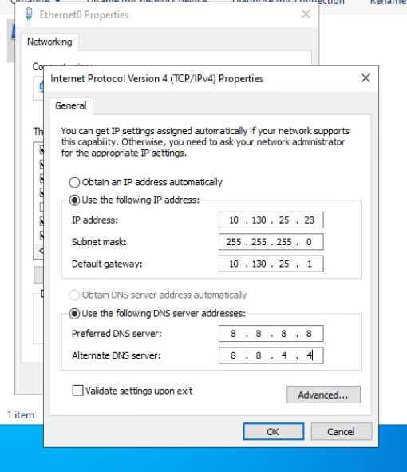

## Practice:

We installed a windows server on a virtual machine with the help of vCenter (a platform for managing virtual infrastructure).

We changed the IP Address on the windows settings (image)

To have access to the internet we needed of course to insert a DNS.

The general DNS are: 8.8.8.8 (primary) 8.8.4.4 (secondary)

We made an update on the windows server and found how to disable updates. (Command prompt 🡪 services.msc 🡪 Windows update 🡪 proprieties 🡪 disable)

! On the vCenter, ISO is for media and VM is for virtual machine.

*Feelings of the challenge (for DTA): It was a little hard sometimes to understand what to do, because of the IT vocabulary that I don’t really have yet, but I had the help of my class colleagues, the file that the teacher provided and google. At the end I was happy because I made it and I could learn more about virtual machines and what’s the purpose of them.*

# 28.09.2022

*Chapitre 1 🡪 C’est une présentation général de tout ce qu’on va voir, il faut juste comprendre 🡪 résumé avec choses importantes dans pdf slides*

A l’époque il n’y avait que le BBS Network. Si on veut voir un film culturel 🡪 WarGames 1983

Cultural movie 🡪 WarGames 1983

Things we need to identify (addresses)

* Ip address you can identify a single machine on the network.
* Kind of communication we are sending to the machine

Each machine has a mac address – physical address. Each maker of the Nic (network interface card) has a number

Elements of communications – 2.1.1

* 1st – sender
* 2nd – receiver
* 3rd – channel

*Segmentation:*

In theory, a single communication, such as a music video or an e-mail message, could be sent across a network from a source to a destination as one massive continuous stream of bits. If messages were transmitted in this manner, it would mean that no other device would be able to send or receive messages on the same network while this data transfer was in progress. These large streams of data would result in significant delays. Further, if a link in the interconnected network infrastructure failed during the transmission, the complete message would be lost and have to be retransmitted in full.

**A better approach is to divide the data into smaller**, more manageable pieces to send over the network. This division of the data stream into smaller pieces is called **segmentation**

Segmentation has 2 primary benefits:

* by sending smaller individual pieces from source to destination, many different conversations can be interleaved on the network. The process used to interleave the pieces of separate conversations together on the network is called multiplexing.
* 2. segmentation can increase the reliability of network communications. The separate pieces of each message need not travel the same pathway across the network from source to destination. If a particular path becomes congested with data traffic or fails, individual pieces of the message can still be directed to the destination using alternate pathways. If part of the message fails to make it to the destination, only the missing parts need to be retransmitted

*Il a sauté 2.1.5 et 2.1.6*

## Pratique:

**Exercise 1**

What do I need to make the simplest network?

* Une image contenant texte

  Description générée automatiquementPDU (PROTOCAL DATA UNIT)

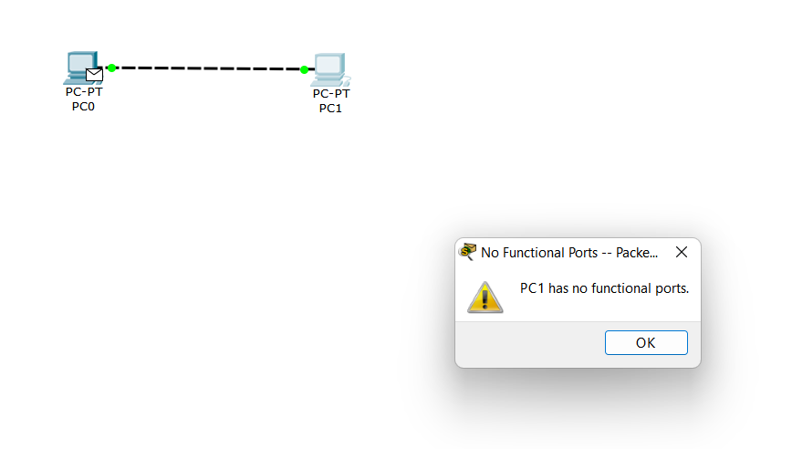

* Physical we connected the machines, but we didn’t configurate them.

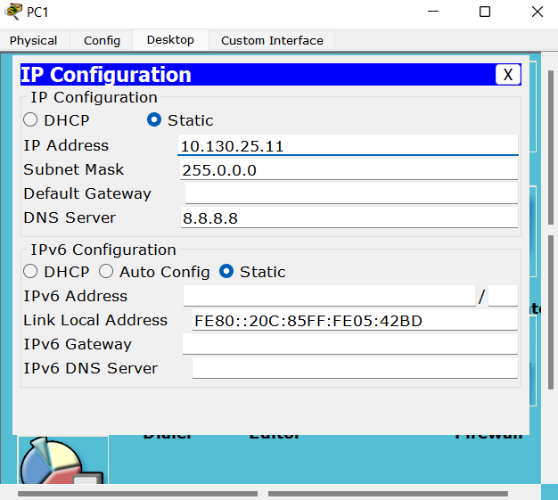

* We need to configure the Ip
* The subnet appears automatically

*A simple network just needs an IP configuration.*

Simulation mode

Internet control message protocol. Gives feedback of the network state

*Tips for the simplest network

- We need to put the envelope in the PC0 and PC1.

- There’s a real mode and a simulation mode

**Exercise 2**

Install WireShark

* Wireshark is a network protocol analyzer or an application that captures packets from a network connection, such as from your computer

We all connected to a WI-FI and we tried to ping each-other

SECURE-HEVS IS CONFIGURED LIKE A BANK – ISOLATED



We can’t ping our classmates, why? Because of the **firewall** that each classmate has. We need to disable it.

We used Wireshark and filter it with:

* ICPM – Internet Control Message Protocol – we use it to manage the information related to the errors of the connected machines

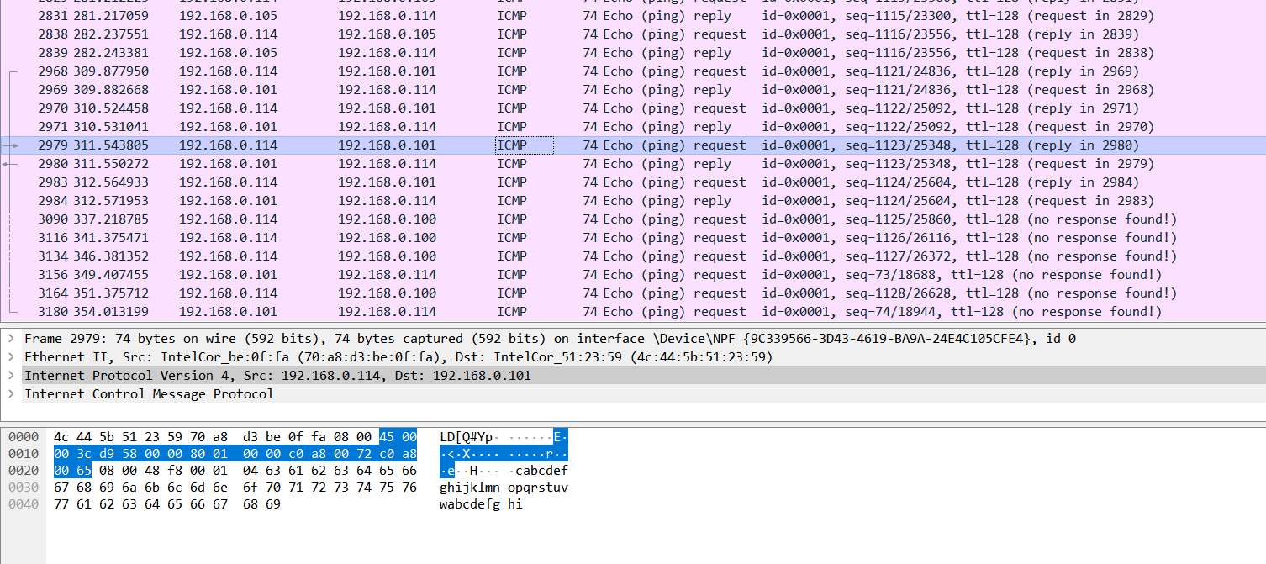

In the following image, we pinged someone and we can see how much bytes we pinged and which ones exactly (by clicking on 32 bytes):

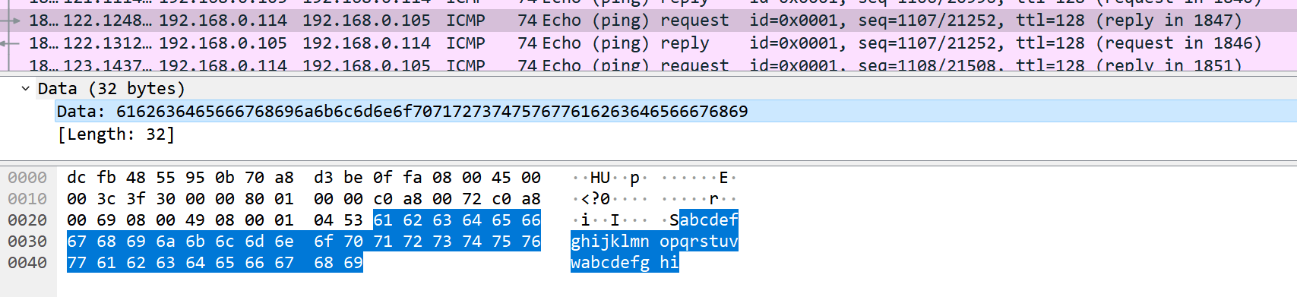

What if we want to ping more bytes?

* We use ping -l size of bytes ip adress



If we don’t know the Ip we can ping the domain name:



We tried to ping [www.google.ch](http://www.google.ch). It didn’t answer. There are 3 possible reasons

* Maybe google has a filter and google doesn’t answer.
* There may have a network between.
* Our local network is secure.

The reason here was the 3rd - In fact our school network doesn’t let ping

Here, I pinged google with my hotspot and it worked:

Here, I pinged Booking and they didn’t answer because they have a filter. (We could still find the Ip address – 37.10.0.220)

**TTL (Time to live)**

* Is a value on ICMP packet that prevents that packet from propagating back and forth between hosts ad infinitum.
* On Mac/Linux – 64 – On Windows – 128

When we ping on local, we have a round TTL number. Outside not. Outside we always have a little less. It’s like someone remove the value of the outside machine and me. The difference number evaluate the distance between me and the machine.

* Example: I got 113 – so 128 🡪 the difference is 15

Each router removes some TTL. If it come to 0, the packet is removed.

* We can reach any machine in the globe with 64.

*Tips for exercise 2

* Various commands:
  + To know our Ip address 🡪 ipconfig
  + Ping/help 🡪 tells us various ping commands
  + /Help 🡪 tells us various commands on the command tab
* If we use the upper arrow, we can have the latest commands that we have done
* Ping is usually to know if the person that we want to communicate with is there
  + We can also use it to detect if a site is failing or if it’s our network problem

# 05.10.2022

Invite des commandes 🡪

What does the commande tracert do? 🡪

Tracert + link (Windows) 🡪 ex. tracert www.google.ch

It’s the fault of our network (Secure Hevs)

Try with phicomm – doesn’t have wifi

Let’s try with hotspot:

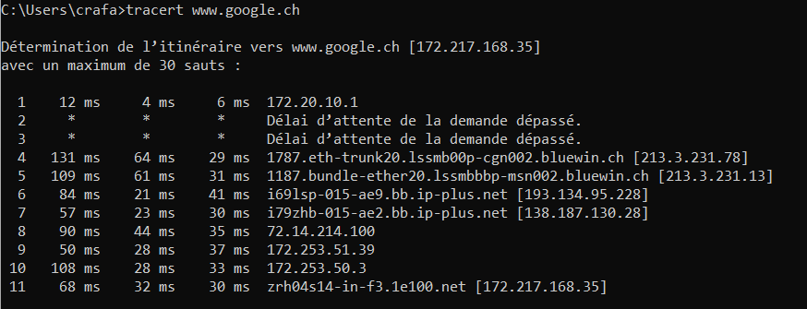

In the 11 I’m connected to google.



Bluewin 🡪 Swisscom – Zurich serveur

What is the difference between tracert and ping?

* With tracert, we can see all the route till we reach the machine. We see each intermediate network

Use wireshark to understand the mechanism to get information between me and final destination (google).

Quand on ping:

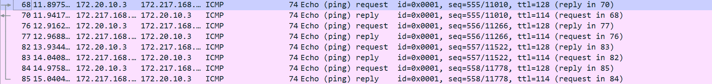

1st thing – they have the same protocol – ICMP

1ST lign we connect to google

If we check the source, we find the things that are on command

But there is a problem 🡪 info – Time to live exceed in transit

We provoke an accident because we want him to answer?

* Because we initialize with 1 and not 128
* Second lign we started with 2
* …

When there are * they maybe disable error answer.

_



We see that in the 4th lign we couldn’t get a response.

_

Exercice : try to tracert a long way - ! careful – by the default we cant go over 30 hoops – how to change it

Change hoops

How to tracert other places?

* Search a website made in USA 🡪 for example Microsoft, madeinamericastore, www.netflix.us

The more lines we have, the more routers we pass.

When * * * * keeps repeating the packet is lost.

* Tip – ctrl + C – stops it

If we want to know which country, we are connected to:

* Google – where is (ip)
* Prendre ip

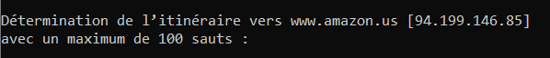

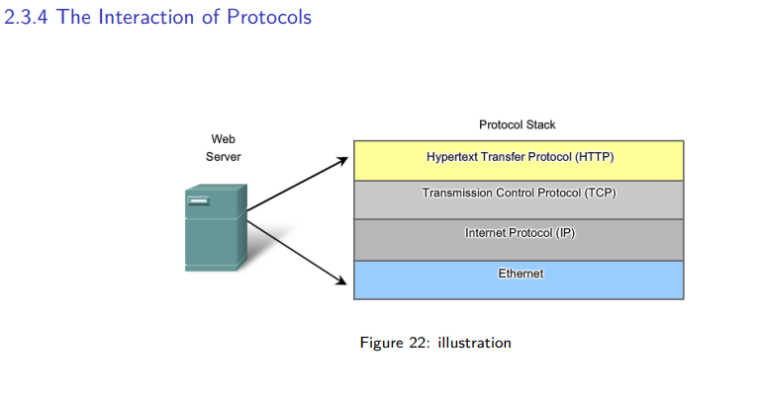*2.3.4 The Interaction of Protocols*

Ipv4 🡪 32 bits

2^32 – 4 milliards

Ipv6 🡪 128 bits

2^128

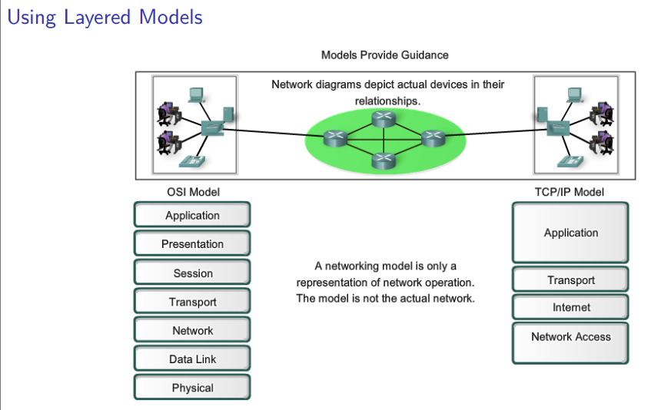

2 different models but for the same purpose 🡪 one is more specific

OSI (we’ll see more in details)

* Application – get/post... “je veux du café »
* Presentation – compress a message or convert it
* Session – manage identification of user
* Transport – ID of a single communication
* Network – ID of the machine
* Data link –
* 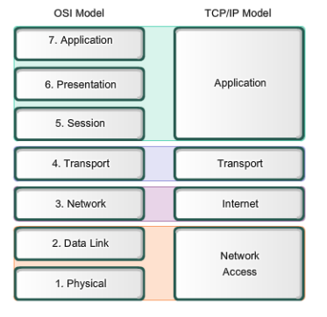Physical – I’m on internet or Wi-Fi

We prefer the 4 layers:

* Cause it’s easier

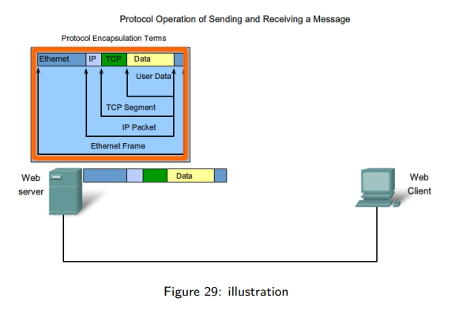 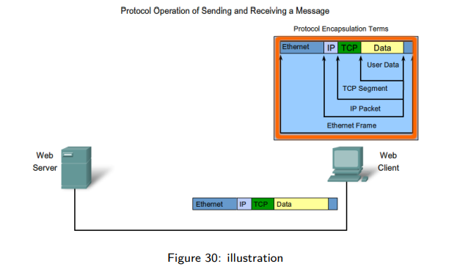 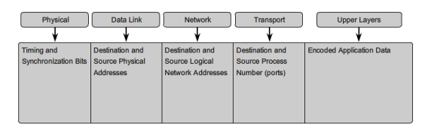

Command to get the status of all these lines (when we send an email, download a file…)

* + Netstat
  + Netstat -an
  + Une image contenant texte

    Description générée automatiquement

When we have a number, we have an encoding and a decoding. And we have a limit!

16 bits - 2^16 – tcp/udp (we still don’t need to know)

TCP is when we call someone (for example) we make a connection and speak…

UDP is talkie-walkie – connectionless

Demo how to communicate with an application that is on internet:

[www.perdu.com](http://www.perdu.com) – simple and not secure



Different layers (cest a lenvers de base c hypertext vers lhaut)



PUTTY IS like a phone -- click on enter 2 times so that it works!

* 80 is default port for web servers

* No spaces between hosts

Why do we put host? 🡪 because there are many sites on the server 🡪 we need to make sure we want this one

**To help me understanding the course: LINKEDIN LEARNING – RESEAUX**

# 12.10.2022

**IP = 192.168.0.100 (octet) 4 byte 🡪 32 bits. What do the numbers mean?**

**1 byte(192) dot 1 byte (168) dot 1 byte(0) dot 1 byte (100) 🡪 regarder photo**

**2^32 bc 🡪 2^(4*1byte)=2^32**

**1 byte = 8**

**192 – diviser par 2 – de droite à gauche – si entier 0 sinon 1**

**1 1 0 0 0 0 0 0**

**168**

**1 0 1 0 1 0 0 0**

**0**

**0 0 0 0 0 0 0 0**

**102**

**0 1 1 0 0 1 1 0**

**Il faut avoir 8 cases**

**Voir photo**

**Quand on a un 0 on remplit avec 8 0 cause we have to fill the byte**

**REVOIR BYTE BITS OCTET ETC...**

**_**

Ip configuration : we put the ip address then enter

We have something else with the IP Address 🡪 Subnet mask (it appear automatically)

255.255.255.0

Let’s try to put it as binary:

1 1 1 1 1 1 1 1 . 1 1 1 1 1 1 1 1 . 1 1 1 1 1 1 1 1 . 0 0 0 0 0 0 0 0

IP =

To know the network we put the IP and the Subnet Mask 🡪 NETWORK (Street)

**1^1 – 1**

**1^1 – 1**

**0^1 – 0**

**Etc….**

**11000000.10101000.00000000.000000000 – THAT’S THE NETWORK (THE STREET NUMBER) (voir photo)**

**If we convert it as decimal:**

**192.168.0.0**

**We have :**

**IP – 192.168.0.102**

**MASK – 255.255.255.0**

**NETWORK : 192.168.0.0**

**Host : reverse MASK (1-0) (0-1)**

**00000000.00000000.00000000.11111111**

**AND THEN WE ADD IT TO THE IP WITH AN AND:**

**00000000.00000000.00000000.01100110**

**HOST 🡪 0.0.0.102 🡪 Host (building number)**

To communicate between machines we must be in the same NETWORK. Otherwise we can’t not communicate. (I have to be in the same street. (metaphor)

Prof prouve it with packet tracer

_

1st machine of 1a network – 192.168.0.1

Last – 192.168.0.254

How to find it? 1st machine on the network

Only take the red part (HOST)

Everything 0 except the last – 00000001

How to find the last one?

You put only 1 excepts the last (0) – 11111110 🡪 254

What if we put only 1? – 11111111 🡪 255

255 is a broadcast address 🡪 that means everybody in that network (you send a message to all the buildings)

_

What will be the next network?

The network part is the 3 first bytes – the host the last one

ADD 1 at the network part:

Next network 🡪 192.168.1.0

Next 🡪 192.168.2.0

Switch – multi plug (developer def)

Static – doesn’t change

_

Answer theses questions connected to SECURE HEVS:

What’s your IP address?

10.93.7.225

Are you in the same network as your partner?

What’s the valid rang of your network?

What’s the next network?

1. 10.93.7.225 - mask 255.255.0.0
2. We have the same network.
3. 10.93.0.1 till 10.93.255.254
4. 10.94.0.0

_

Why sometimes they are 1 255 – 2 255 - 3 255?

How many streets can I have?

Tout en bas – petite partie réserve pour les hôtes 🡪 254 (0-réseau lui-même / 255-broadcast) (small)

Average – 2^16 (16 bytes) – 65536 (addresses théoriques) – reseau/broadcast 🡪 65534 adresses valides

Huge – 2^24 – 16 777 216 -2 = 16777214

What is the counter part?

Ça inverse pour les réseaux !

Average – 2^16 – 64k

Huge – environ 255

How do we know when we put a value the subnet?

Ex – 10.0.0.1 🡪 255.0.0.0

When the binaire part of the 1st part(10) is a 0 🡪 class A (huge) – environ 128 réseaux de classe A dans le monde

2^7 -> 128 (toutes les chiffres possible commençant par 0)

Classe B : 1 0 - 2^14

(Etat du Valais OU reseau scientifique valaisan a la classe B)

Classe C : 1 1 0 – 2^21

TOUT CA C PAR DEFAUT

Apres on peux faire comment on veux

On peux agrandir la partie verte.

_

On a depasse la limite de 2^32 avec ipv4 – 4 milliards

Comment ça se fait ? grâce au Nat

Y a des adresses spéciales qui peuvent être réutilisés :

* 10.0.0.0(A) – adresse privé
* A la maison souvent 192.168.0.0©
* 172.16.0.0 (B)

Pour une adresse on peux avoir plusieurs machines.

Il faut un nat pour que ça fonctionne

4 milliards de nat. Network adress Translation)

VPN – Port forwarding

Redirige vers differentes addresses IP ?

# 19.10.2022

DNS – Domain name system

url without a subdomain : <http://www.cisco.com>

* http : protocol
* www : host name
* cisco : domain name
* com : top level domain

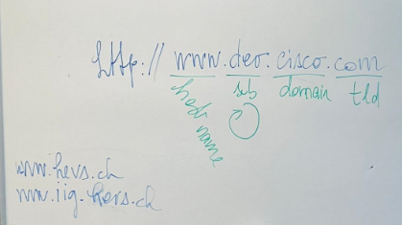 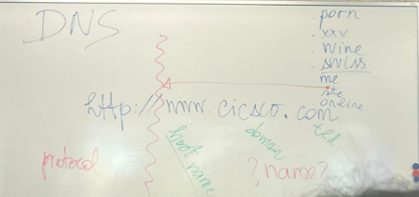

How does the server work to give us the IP? (-com 🡪 Ip)

Imagine your in the school and you are the first user to put [www.cisco.com](http://www.cisco.com) in my browser:

It is a dns request that we go from our computer to the resolver.

Quell ip on aura

NSLOOKUP (chercher explication)

FILTER WIRESHARK WITH DNS

We have the queries and the answers (voir photo)

IPCONFIG /ALL

WE HAVE 2 DNS SERVERS. IF ONE DOESN’T WORK WE USE THE OTHER ONE. BUT WHY DO WE HAVE 2? – for liability

But why do we need liability in dns and not others?

* The directory doesn’t work.

[Why does ipconfig show multiple DNS servers? - Super User](https://superuser.com/questions/187046/why-does-ipconfig-show-multiple-dns-servers) – chercher sur internet

Chapter 3!!

**Be able to find dns on wireshark, analyze what we are asking etc…**

**PACKET TRACER:**

* [DNS server configuration in Packet Tracer – Computer Networking Tips (wordpress.com)](https://computernetworking747640215.wordpress.com/2018/07/05/dns-server-configuration-in-packet-tracer/#:~:text=Configure%20DNS%20service%20on%20the,and%20their%20corresponding%20IP%20addresses.)
* http and dns connected to a switch (not empty) connected to the PC
  + configure the pc, configure http, configure dns
  + then test **🡪 web browser site (see image)**

go on laptop commandprompt 🡪 ipconfig

DHCP

---- PAUSE ----------

Broadcast

Théorie : chapiter 3 – page 20 / 29

DNS – DHCP

Theorie . chapter 4:

TCP / UDP:

Voir photo

With DNS is UDP

_

Tcp and Udp difference – chapter 4

Udp is smaller

_

* + 1. – 4.1.4 – 4.1.5

# 26.10.2022

Comment savoir si un port est ouvert ou pas ?

* Avec putty
* Si c’est noir ok – pas forcément
* Open wireshark

Filter – tcp.port == xxxx (port)

* Look picture
* The server doesnt answer
* IMPORTANT – 3 ligns when he answers

When it doesn’t work:



When it works:



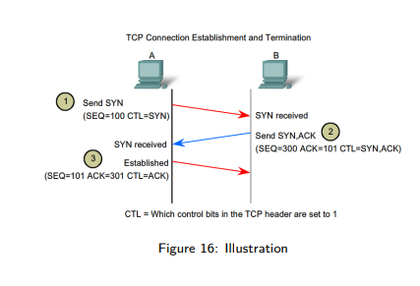SLIDE 4.2.3 TCP Connection Establishment and Termination

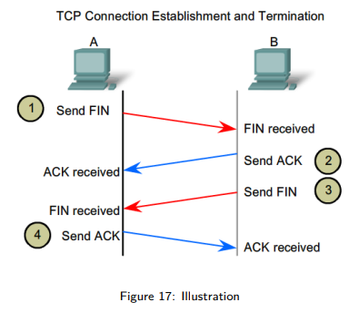

Slide 4.2.4

4th lign I want to finish the conversation and I acknowledge

6th lign the server want also to finish the conversation and acknowledge

(Finish is a polite conversation of 4 ligns)

(WE DIT IT WITH TCP)

Lets do it with HTTP:

* NOW WE KNOW CONNECTION AND DECONNECTION

4.3.4

Window file – manage the flow – quantity of data that you agree to receive

_

1. Xx
2. 153.109.0.0/16
3. 153.110.0.0

Trouver 2 adresses:

153.109.0.0/16

-- trouver adresse (chose des cours d’avant)

We need to find network and host:

Subnet mask – 255.255.0.0

Ip in binary:

Response: 103.109.0.1 – 153.109.255.254 – 153.109.255.255

_

GATEWAY IS A ROUTER THAT CONNECTS NETWORKS:

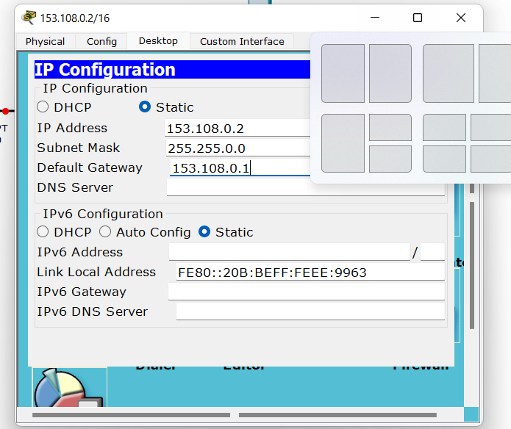

Router

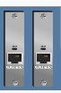

Interface 🡪 fastethernet

How to know how to configure?

Preferences – always show port labels

It shows us

Always switch on the port

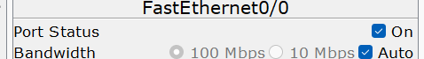

Envelope – is doing a ping

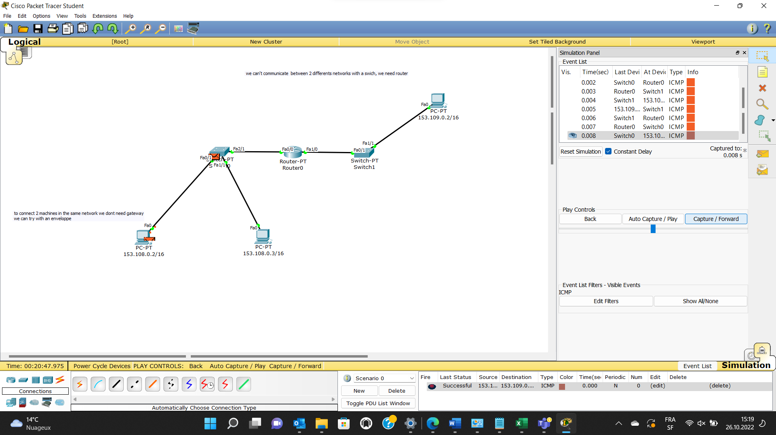

Comment what happen:

Im I in the same network as the destination? No – so gateway

Gateway – Am I connected to the destination network? Yes

* Routing table

Add a rout:

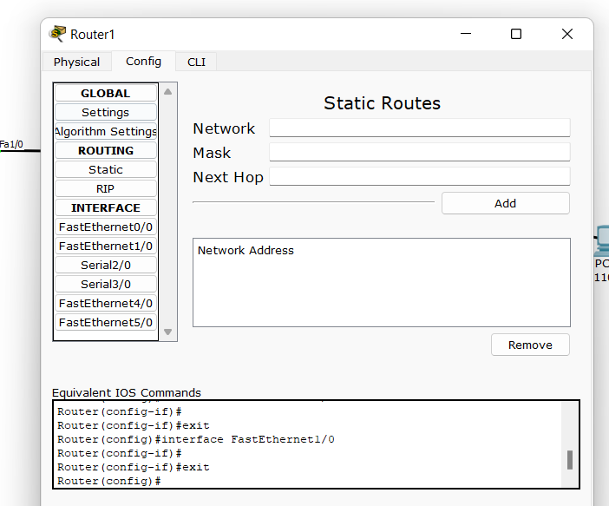

Next hop – adresse la plus proche

Comment aller routing table – utiliser loupe

# 09.11.2022

Subnet work

192.168.0.0/24 - We want to have 2 networks with it:

24 is the size of the green part

Binary:

# 16.11.2022

12.0.0.0/8 🡪 divided in 16

DOCUMENTER pour nous aider sur packet tracer

Exercice fait en classe (réussi a faire juste un peu embrouillé avec les chfr, pour static, à revoir) :

Corrigé sur cyberlearn

Suite du cours

* On a divisé en réseaux de tailles identiques
* Ça peut être un problème

192.168.80.0/24

192.168.80 🡪 partie verte

Donc on peut mettre 254 réseaux

# 30.11.2022

Rip c comme next hop

Metrics : 120/4

* 4 is the number of hops (routers that we passed)

Résoudre partie en reseau (réseau 17)

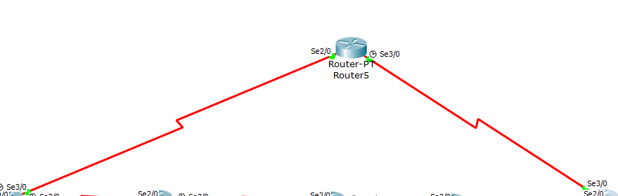

BETTER than RIP :

OSPF

Commande activer ospf :

Router ospf 1

EXIT POUR QUITTER

Comment choisir le meilleur chemin ?

Passer par en haut ou par en bas.

Command to slow down :

Router.config#interface serial 3/0

Config-if# Bandwidth 1

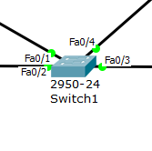

On peux connecter 24 machines dans ce switch et elles communiquent entre elles.

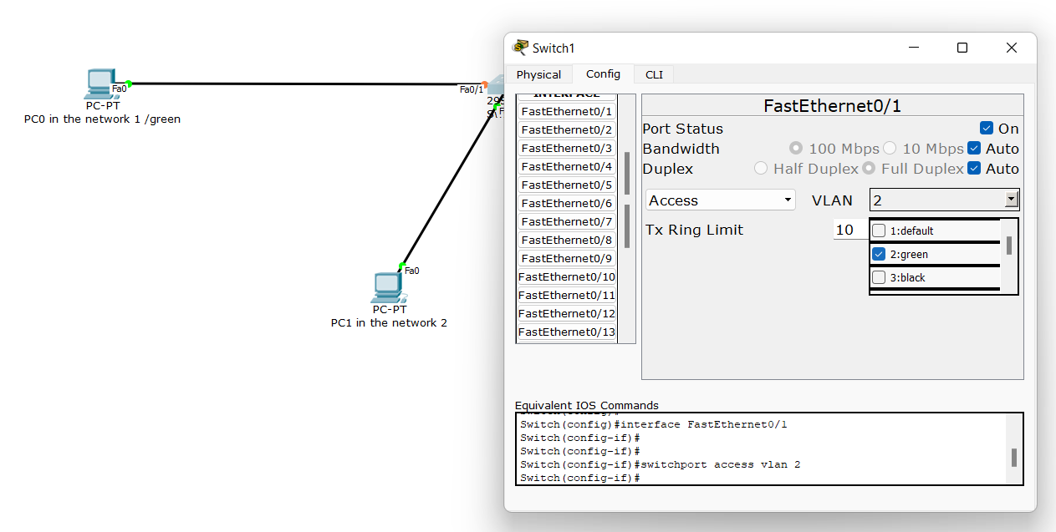

How to communicate between 2 networks?

With a router

How to configurate it so it can connect to the 2 networks?

07.12.2022

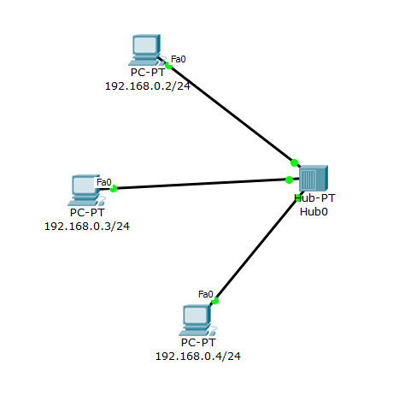

Hub : ça envoie à tout le monde l’enveloppe

Il la reçoit mais l’oubli.

Problème : sécurité, performance (une des raisons pour laquelle on utilise pas l’Hub actuellement, nowadays)

Switch :

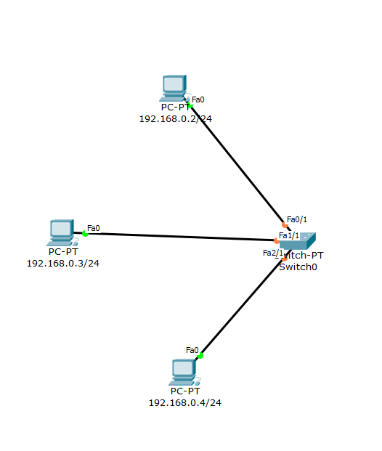

Le switch envoie que l’enveloppe au destinataire voulu.

C’est mieux un switch que d’avoir Hub.

_

Arp protocol

Relationship between an Ip and a mac address .

